ANSIBLE - TASK – 02
==============================================================================

- Watch ansible-02 video and write down notes.
- Install httpd using ansible playbook, use handlers,notifiers.

- log in to the Ansible controller node as root.
- run:
- ansible all -m ping
- Ansible connects to all hosts in the inventory.
- Both worker nodes return SUCCESS with pong.
- Python interpreter /usr/bin/python3 is detected automatically.
- create a directory for Ansible playbooks:
- mkdir playbooks
- move into the directory:
- cd playbooks
- create and open the Apache playbook:
- vi apache.yml
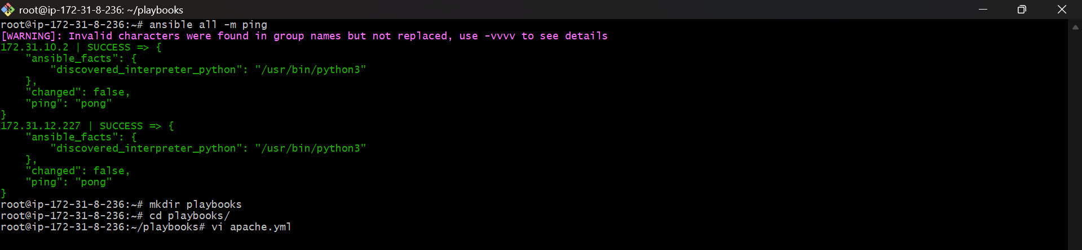

- Targets all hosts:
- hosts: all
- become: yes
- Installs Apache:
- apt:
- name: apache2
- state: latest
- update_cache: yes
- Copies index.html to Apache web root:
- copy:
- src: index.html
- dest: /var/www/html/index.html
- Triggers handler when file changes.
- Handler restarts Apache:
- service:
- name: apache2
- state: restarted
- Result
- Playbook fully defined with tasks + handler.

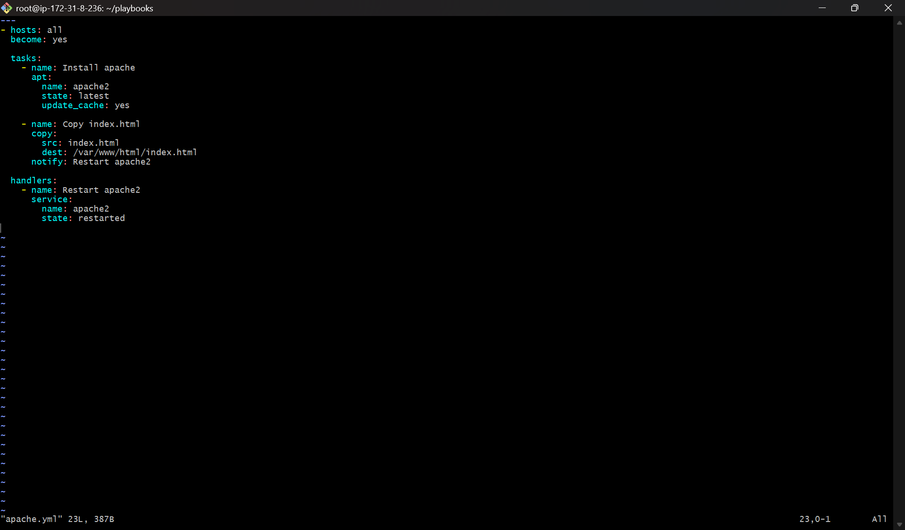
- Syntax validation:
- ansible-playbook apache.yml --syntax-check
- Dry run (check mode):
- ansible-playbook apache.yml --check
- Tasks are evaluated but no real changes applied.

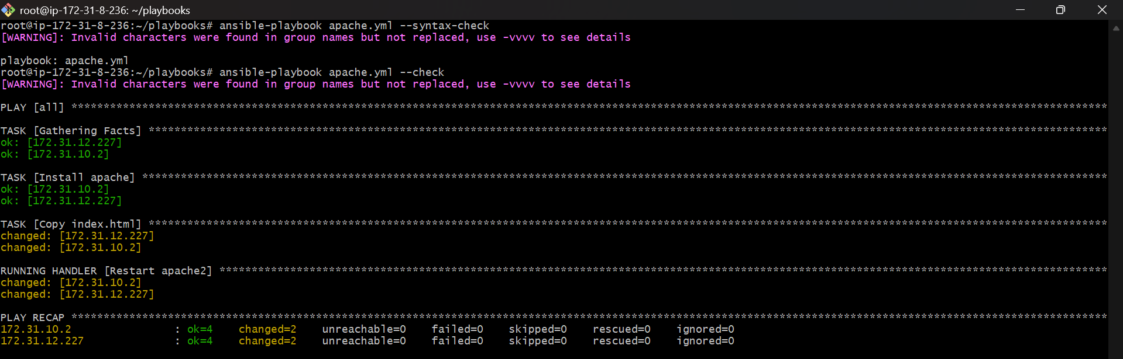
- create the HTML file:
- touch index.html
- edit it:
- vi index.html
- Add content:
- hello this is from ansible controller
- Web page content is ready to deploy.

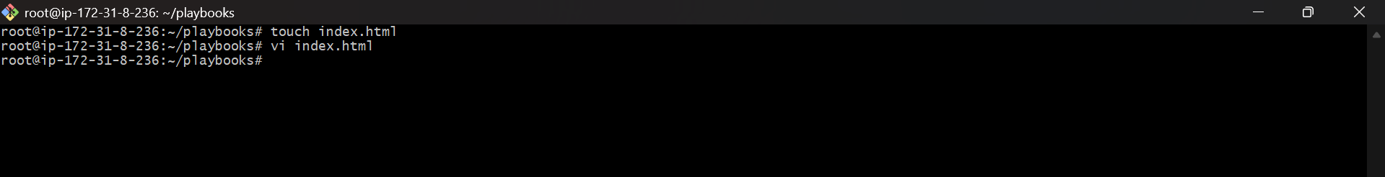

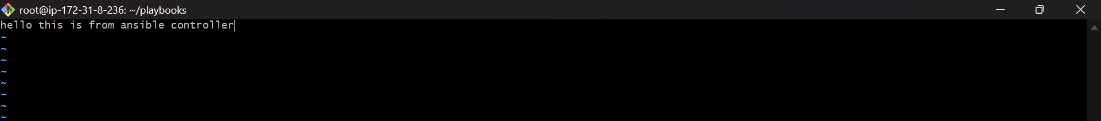
- Execute the playbook:
- ansible-playbook apache.yml
- Ansible:
Gathers facts
Installs Apache (if not already)
Copies index.html
Restarts Apache via handler
- Output shows ok and changed.

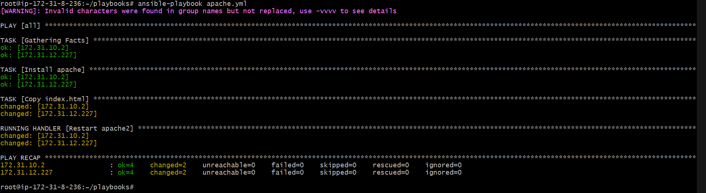
- You open both EC2 worker instances.
- Check Apache service:
- systemctl status apache2
- Apache shows:
Active: active (running)
Service enabled at boot.
- Instance details confirm:
ANSIBLE-WORKER-01
ANSIBLE-WORKER-02

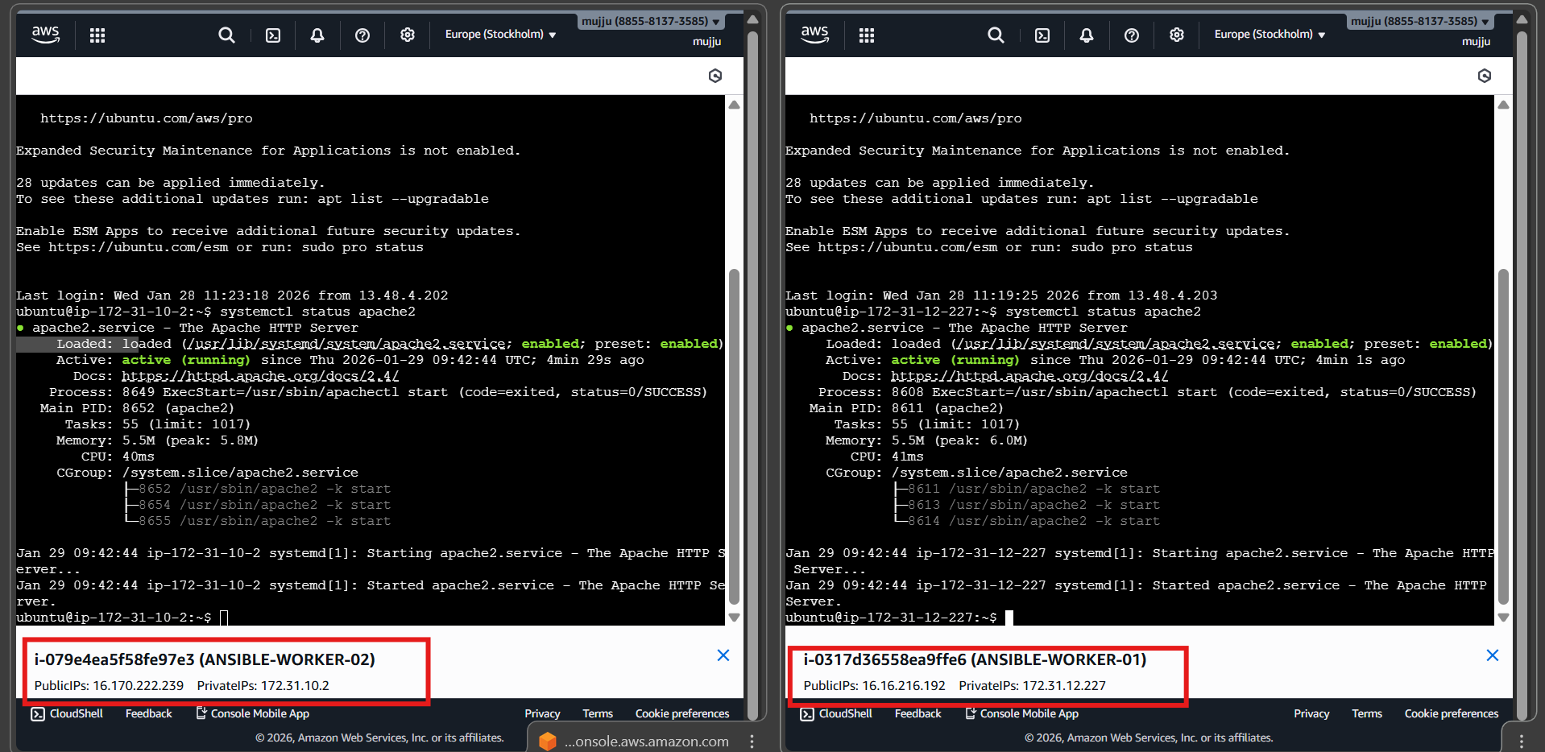
- Worker 1
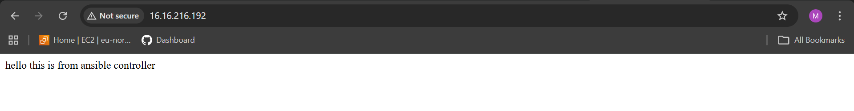

- Worker 2


- Write a ansible playbook to install apache tomcat.
- Login to Ansible controller.
- Switch to root user.
- Go to playbooks directory.
- Create a file named tomcat.yml

- Run:
- ansible-playbook tomcat.yml

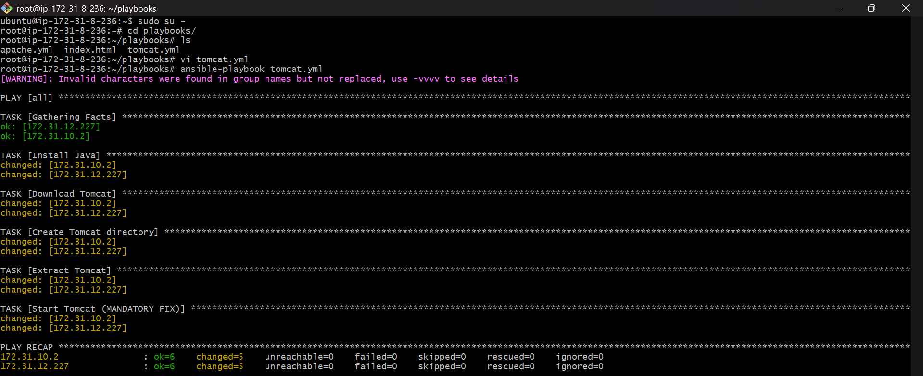
- Steps inside tomcat.yml
- Target all hosts with privilege escalation:
hosts: all
- become: yes
- Install Java:
- apt:
- name: openjdk-11-jdk
- state: present
- update_cache: yes
- Download Tomcat:
- get_url:
- url: https://archive.apache.org/dist/tomcat/tomcat-9/v9.0.85/bin/apache-tomcat-9.0.85.tar.gz
- dest: /tmp/tomcat.tar.gz
- Create Tomcat directory:
- file:
- path: /opt/tomcat
- state: directory
- Extract Tomcat:
- unarchive:
- src: /tmp/tomcat.tar.gz
- dest: /opt/tomcat
- remote_src: yes
- extra_opts: [--strip-components=1]
- Start Tomcat manually:
- shell: |
- export JAVA_HOME=/usr/lib/jvm/java-11-openjdk-amd64
- nohup /opt/tomcat/bin/catalina.sh run > /opt/tomcat/logs/catalina.out 2>&1 &

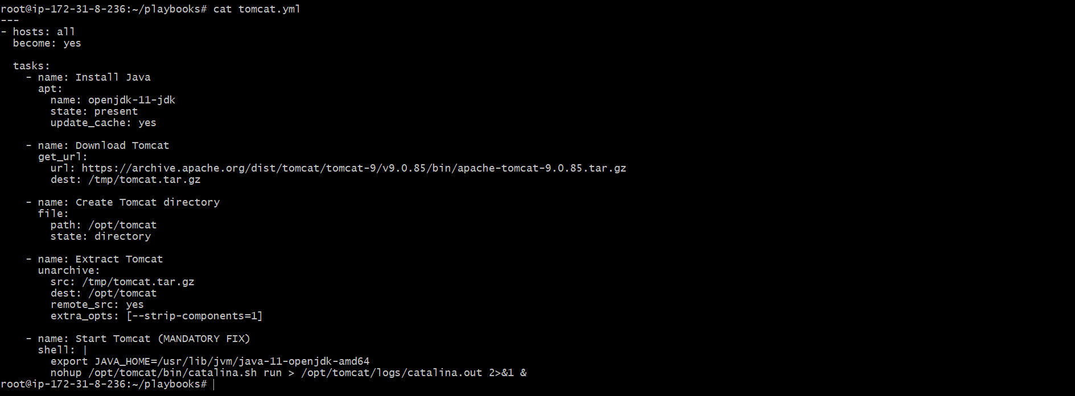
- Copy public IP of worker node 1.
- Open browser.
- Go to:
- http://<public-ip>:8080
- Tomcat page appears.

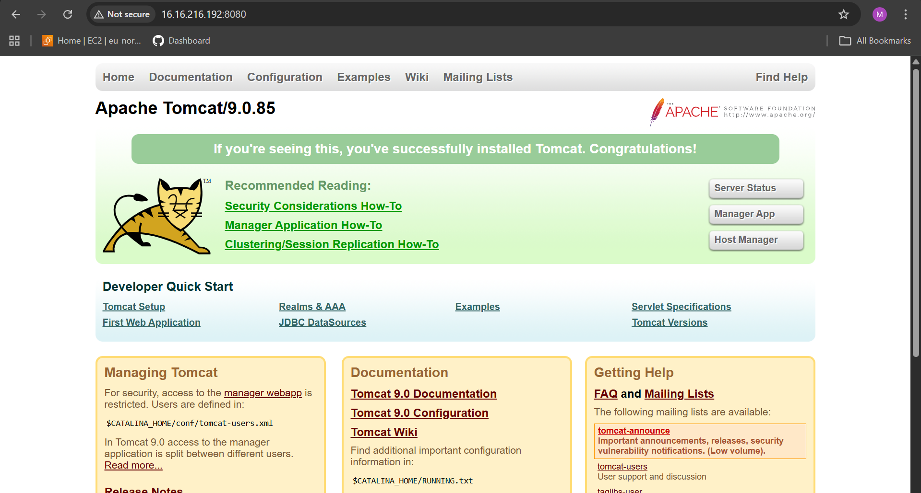
- Copy public IP of worker node 2.
- Open browser.
- Go to:
- http://<public-ip>:8080
- Tomcat page appears.

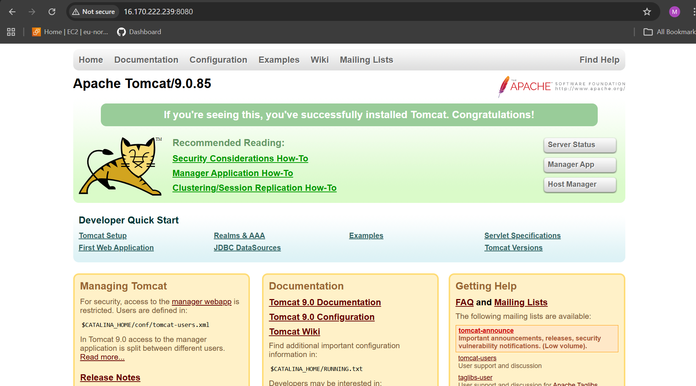

- Write a ansible playbook to provision one ec2 on aws.
- 1️⃣ Install required tools
- apt update
- apt install unzip curl -y

- 2️⃣ Download AWS CLI v2
- curl "https://awscli.amazonaws.com/awscli-exe-linux-x86_64.zip" -o awscliv2.zip

- 3️⃣ Install
- unzip awscliv2.zip
- ./aws/install

- 4️⃣ Verify
- aws --version

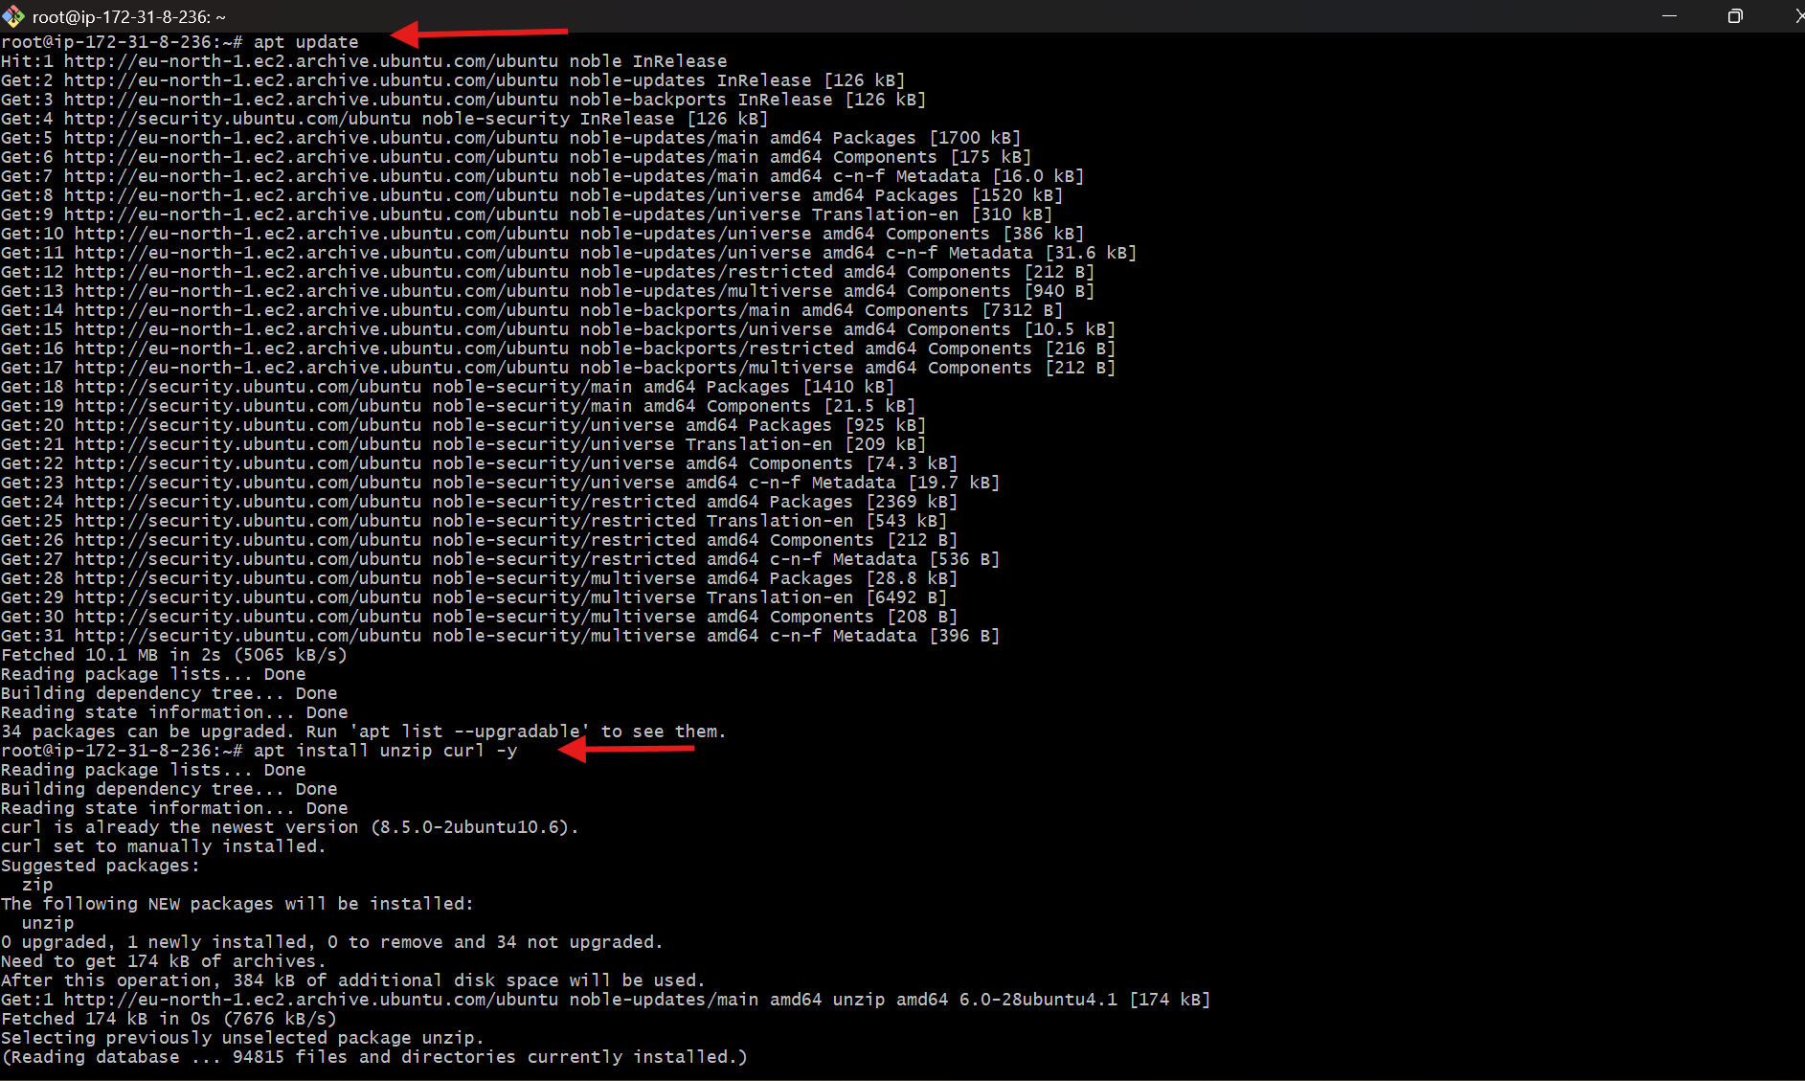
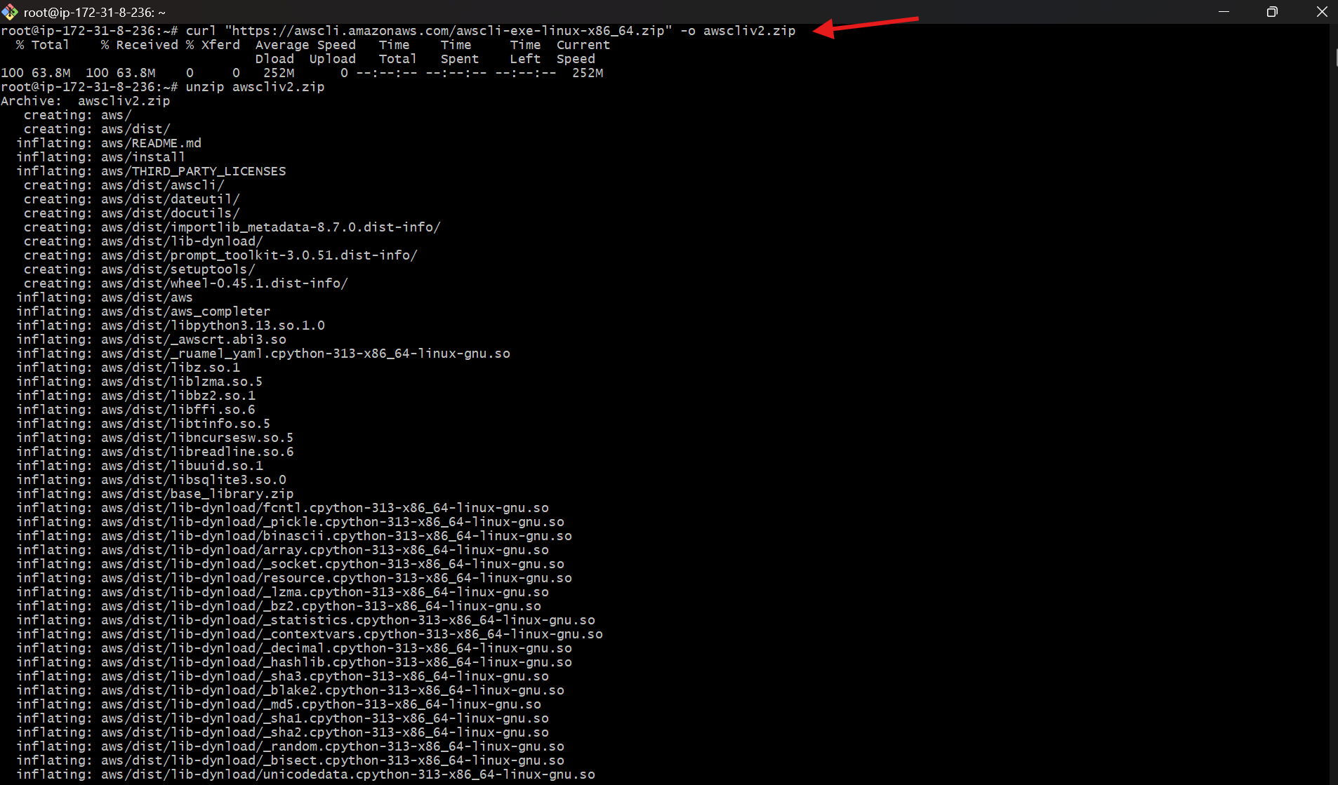

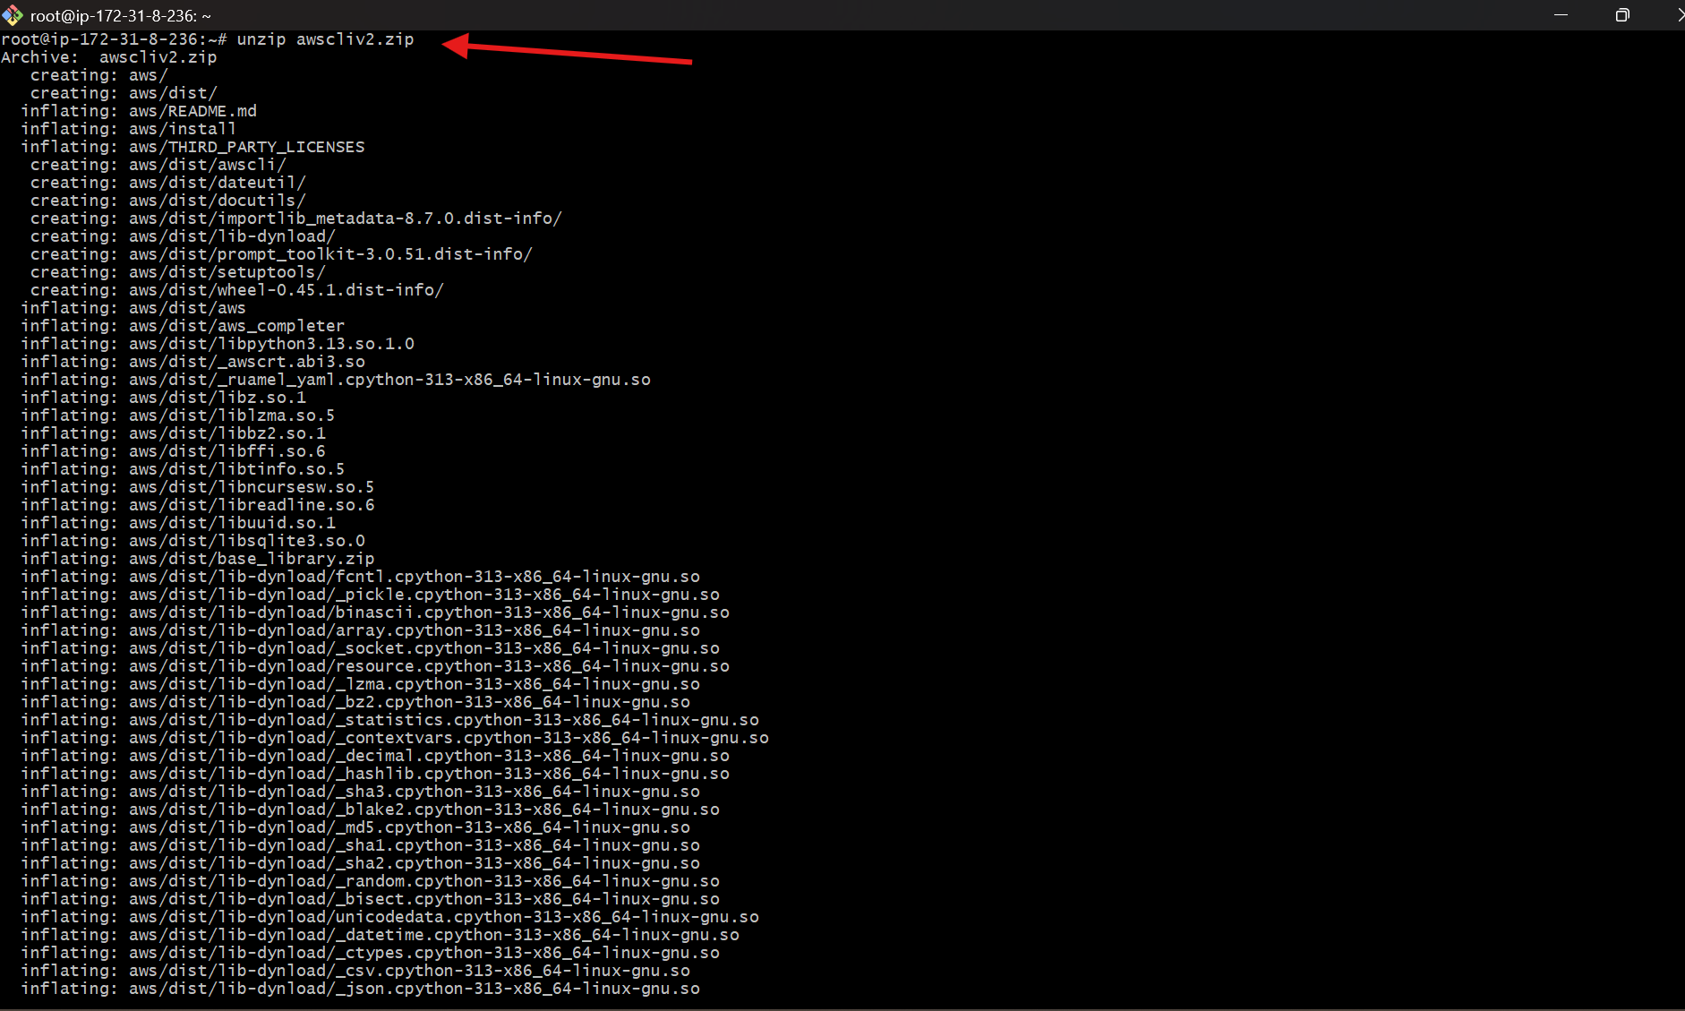

- Run:
- aws configure
- Enter:
- Access Key
- Secret Key
- Region (eu-north-1)
- Output format (json)

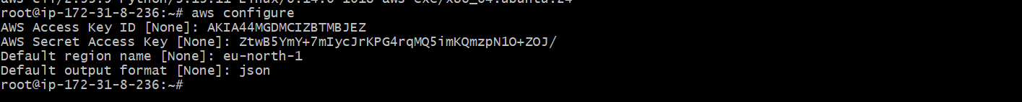
- Go to playbooks directory:
- cd playbooks
- Create playbook:
- vi ec2.yml
- cat ec2.yml
- yaml file is shown
- Check syntax:
- ansible-playbook ec2.yml --syntax-check
- Run playbook:
- ansible-playbook ec2.yml

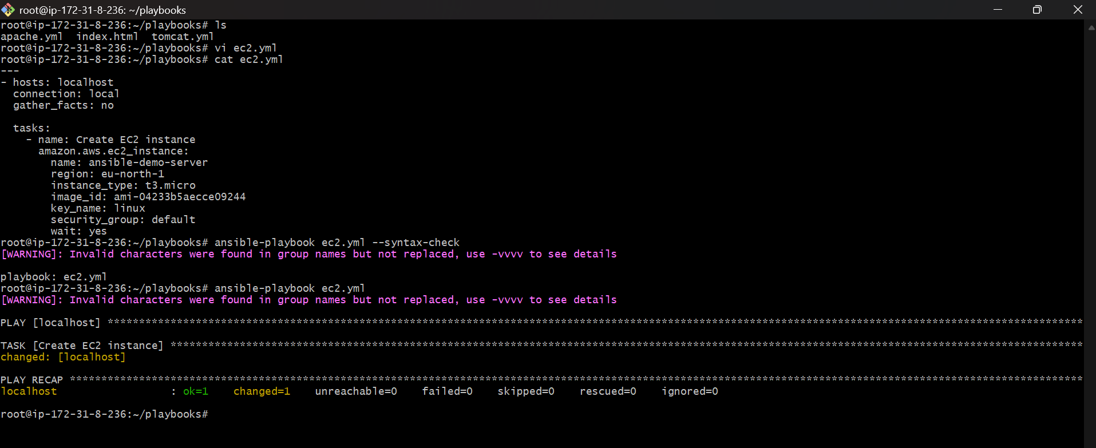

- Open AWS Console.
- Go to EC2 → Instances. Instance ansible-demo-server is running
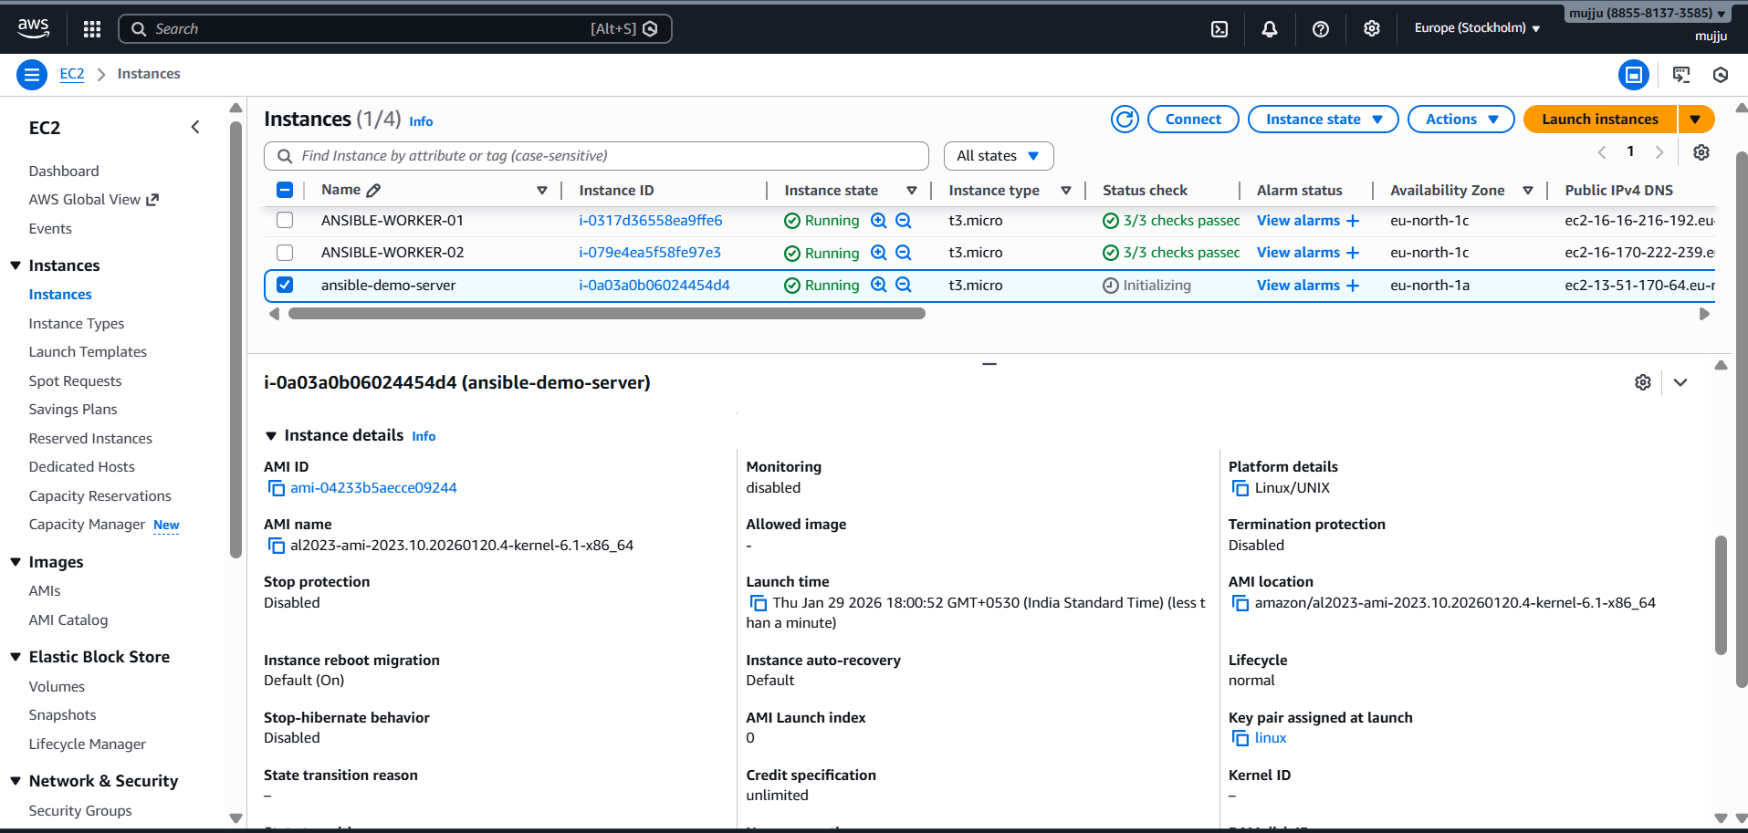

- Write a ansible playbook to copy one file from node-1 to node-2.
- Login to worker-01.
- Go to /tmp:
- cd /tmp
- Create file:
- touch sample.txt
- Verify file:
- ll
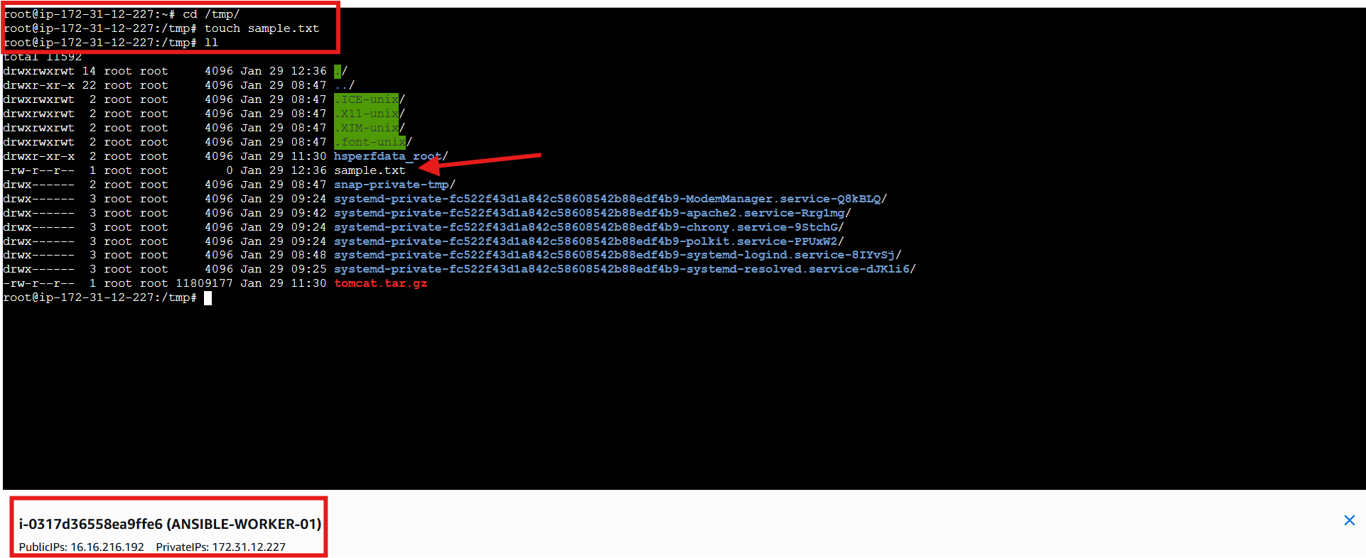
- Create node.yml.
- Fetch file from worker-01 → control node.
- Copy file from control node → worker-02.
- Run:
- ansible-playbook node.yml
- Playbook runs successfully.

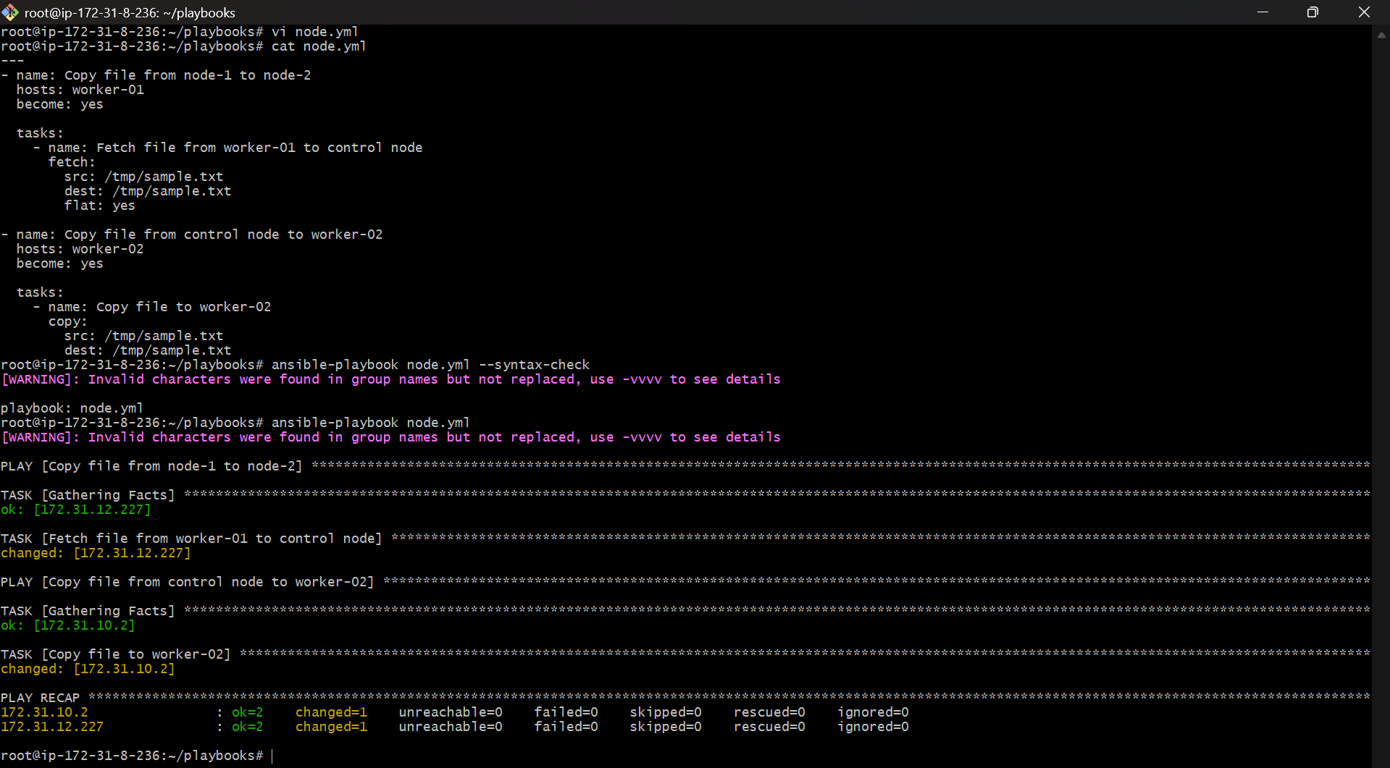
- Login to worker-02.
- Go to /tmp:
- cd /tmp
- Check file:
- ll
- sample.txt is present.

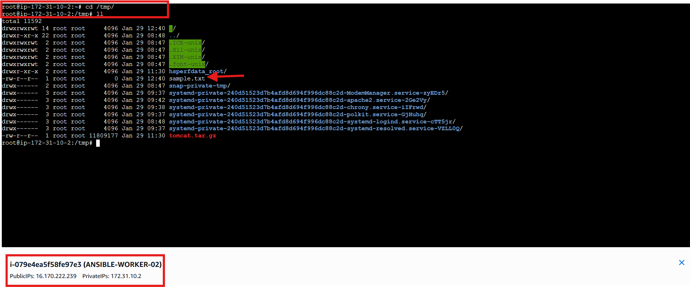

- Write a ansible playbook to create different files with different names using single playbook.

- Go to playbooks directory.
- Create multiple_files.yml.
- Use loop to define file names.
- Run:
- ansible-playbook multiple_files.yml
- Playbook runs successfully on all hosts.
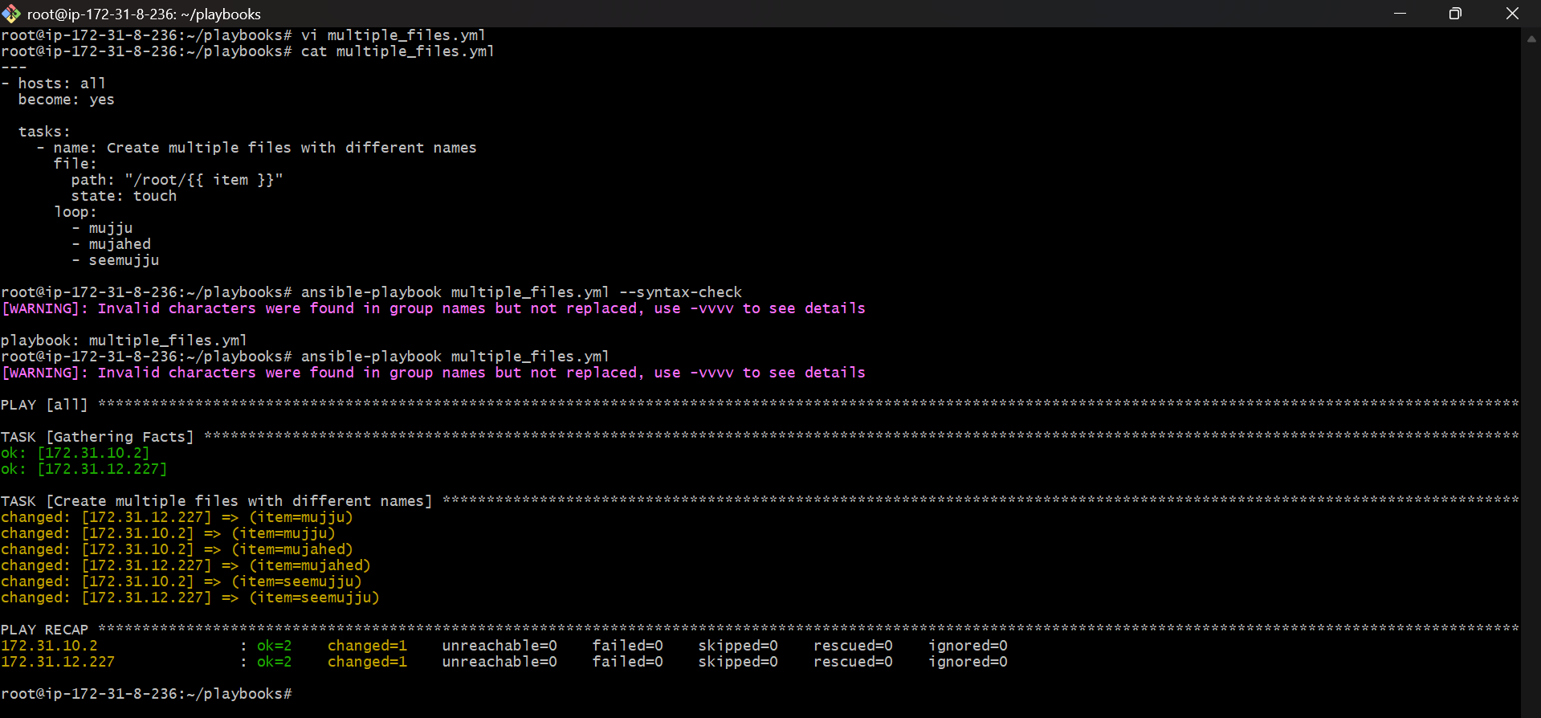
- Login to ANSIBLE-WORKER-01.
- Go to /root directory.
- Run:
- ls
- Files mujahed, mujju, seemujju are created.

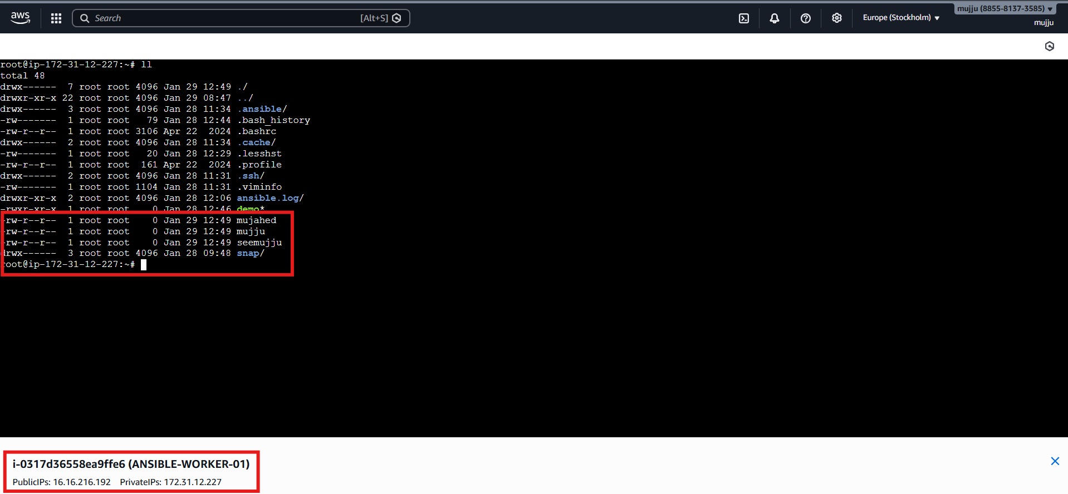
- Login to ANSIBLE-WORKER-02.
- Go to /root directory.
- Run:
- ls
- Same files are present.

